**Computer Networks**



**NMIMS Mumbai**

**Practical Journal in**

# Computer Networks

**Submitted By**

## **Tarun Tanmay**

## **SAP ID: 70471018055**

**Master of Business Administration in Technology Management**

**Computer Engineering Academic Year**

**2020-2021**

**Mukesh Patel School of Technology Management & Engineering**

**Bhakthi Vendanth Swami Marg, Near Cooper Hospital, JVPD Scheme, Vile**

**Parle West, Mumbai, Maharashtra 400056**



**CERTIFICATE**

|  |
| --- |
| **Name: Tarun Tanmay**    **Class: B Roll Number: N049 SAP ID: 70471018055**    **Program: MBA Tech Computer Engineering**    **This is to certify the work of the student in Computer Network laboratory during the academic year 2020-21 has been successfully completed.**          **_____________**  **Examiner’s Sign**      **Date:** |

INDEX

|  |  |  |  |
| --- | --- | --- | --- |
| **SR. No.** | **Title** | **Date** | **Sign** |
| **1** | **Experiment No.01** | 06/07/2020 |  |
| **2** | **Experiment No.02** | 13/07/2020 |  |
| **3** | **Experiment No.03** | 22/07/2020 |  |
| **4** | **Experiment No.04** | 29/07/2020 |  |
| **5** | **Experiment No.05** | 05/08/2020 |  |
| **6** | **Experiment No.06** | 19/08/2020 |  |
| **7** | **Experiment No.07** | 26/08/2020 |  |
| **8** | **Experiment No.08** | 10/09/2020 |  |
| **9** | **Experiment No.09** | 23/09/2020 |  |
| **10** | **Case Study** | 10/10/2020 |  |

## Experiment 1

# B.1: Procedure of performed experiment

1. Programming lab follows the Star topology: without having the need to share the data amongst themselves, they will be working on their individual systems.
2. Project student’s lab follows the Bus topology: The data might be shared amongst each other.

3) Admin area follows Tree topology: In order to maintain the hierarchy, this topology is followed.

4) Faculty area follows Star topology: Different faculties share data of their subject which they respectively work on with the class teacher of the students.

All the systems have their different topologies maintained with the aid of routers and connections.

# B.2: Observations and Learning’s:

Through this experiment, we’ve learned about several networking structures and different topologies like star, tree, and bus that are followed in different domains of computer network.

# B.3: Conclusion:

A successful design was implemented demonstrating the network of a floor.

## Experiment 2

**B.1: Procedure of performed experiment**

Network made:

The network was made as shown above. Each LAN had two PCs, one Switch and one Router. The PCs were connected to the Switch, which in turn was connected to the Router. The Routers were then connected to each other. The left network was assigned the IP address 192.168.1.0 and the components connected to it were assigned IP addresses corresponding to it. The right network was assigned the IP address 192.168.2.0 and the components connected to it were assigned IP addresses corresponding to it. The network connecting the Routers was assigned the IP address 10.12.1.0. No configurations had to be made on the switch as it works on the data link layer.

Configurations of one LAN:

PC0:

For the PC, the IP configuration section under Desktop was filled as follows:

* The IP address assigned to it in the LAN it is connected to was entered (192.168.1.2)
* The default gateway, i.e., the address of router connected to its network, was entered (192.168.1.1)

PC1:

For the PC, the IP configuration section under Desktop was filled as follows:

* The IP address assigned to it in the LAN it is connected to was entered (192.168.1.3)
* The default gateway, i.e., the address of router connected to its network, was entered (192.168.1.1)

Router:

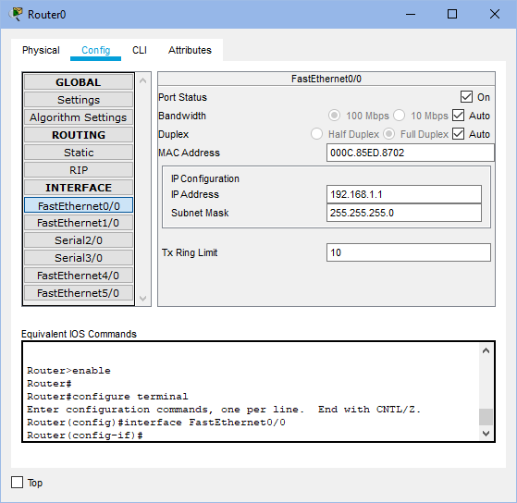

For the router, the FastEthernet0/0 section under Config was filled as follows:

* The IP address assigned to that router in the LAN it is connected to was entered (192.168.1.1)
* The port status was set as ON.

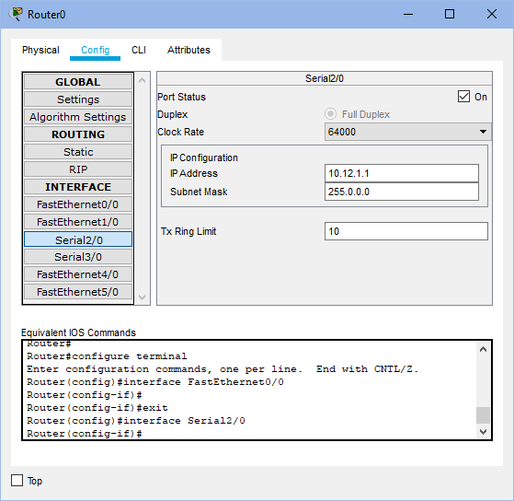

The Serial2/0 section under Config tab was filled as follows:

* The IP address assigned to it in the network between the two routers was entered. (10.12.1.1)
* The clock rate for this router was set as 64000 while for the other router was set as ‘Not Set’.
* The port status was set as ‘ON’.

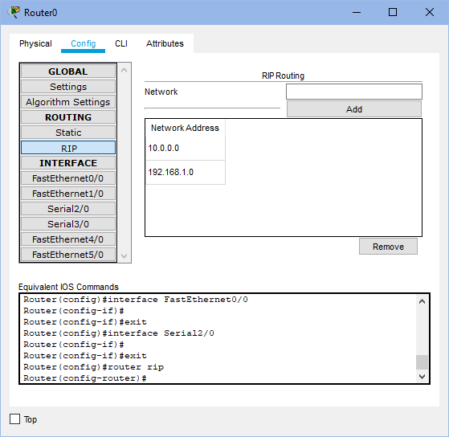

The RIP section under Config tab was filled as follows:

* The addresses of the networks connected to it were entered
  + 10.12.1.0 (corresponding to network between the two routers)
  + 192.168.1.0 (corresponding to the LAN it is connected to)

Packet Transmission:

Cross Network PC-to-PC transmission: (from PC0 to PC3)

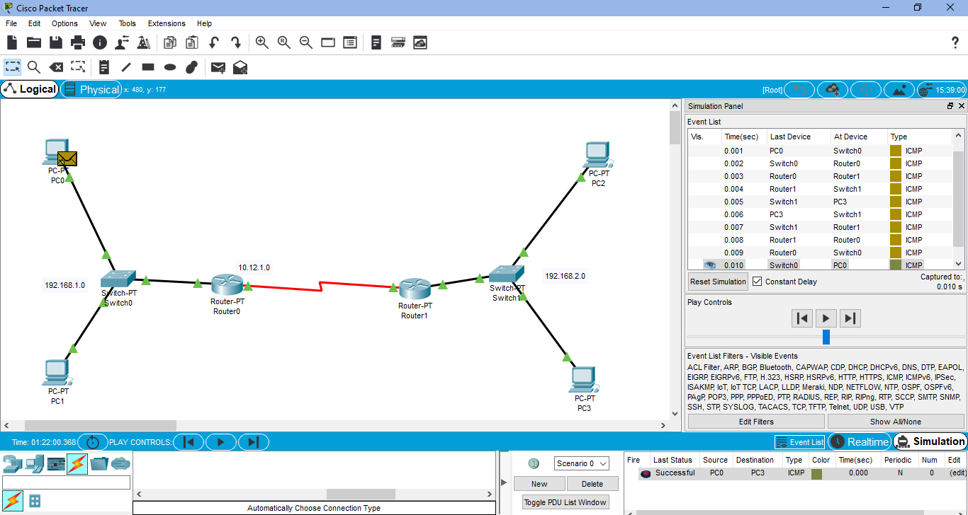

Router-to-Router transmission: (Router1 to Router0)

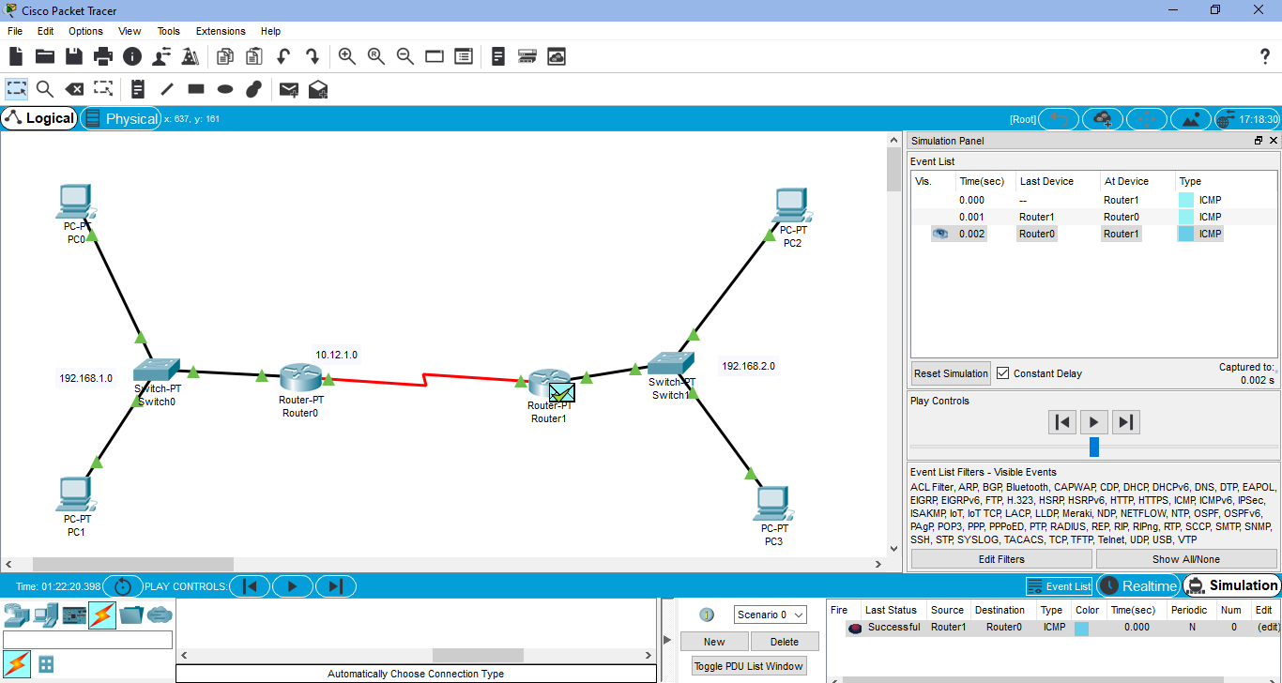

**B.2: Observations and Learning’s:**

Cisco Packet Tracer helps create network topologies using connecting devices, end devices, connections, etc. and simulate the transmission of packets through the network. It gives information about how the packet travels from the source and the destination as well as the components and path used. Changing the IP information of the devices and creating a functional LAN is also possible.

**B.3: Conclusion:**

I have learnt how to use Packet Tracer and create a network as well as see a packet travel in a network from one device to another.

## Experiment 3

**B.1: Procedure of performed experiment**

**B.1: Procedure of performed experiment**

1. Gather TCP/IP configuration information

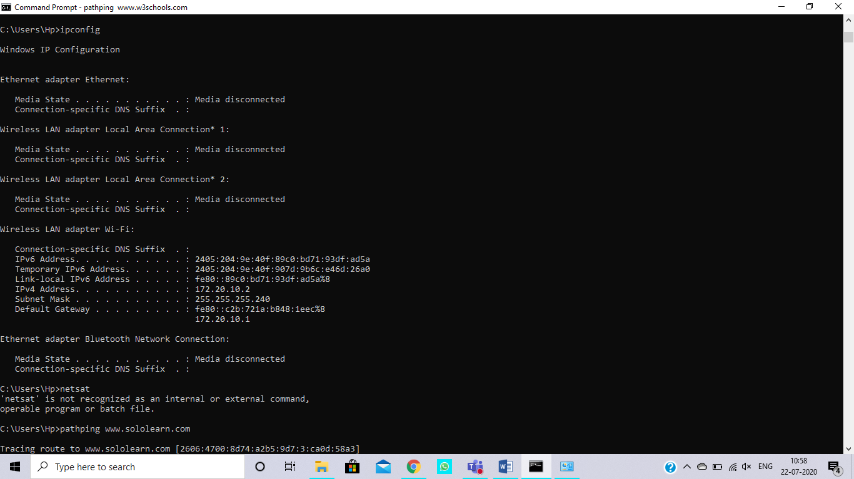

1. Ping the Loopback IP address of your computer

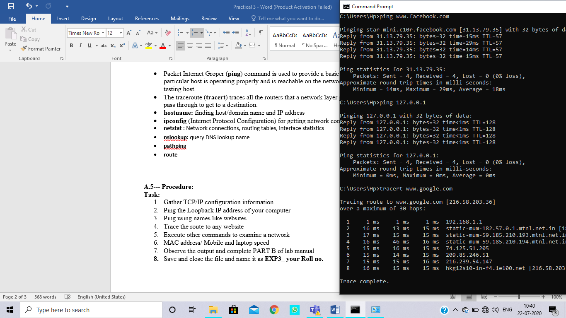

1. Ping using names like websites

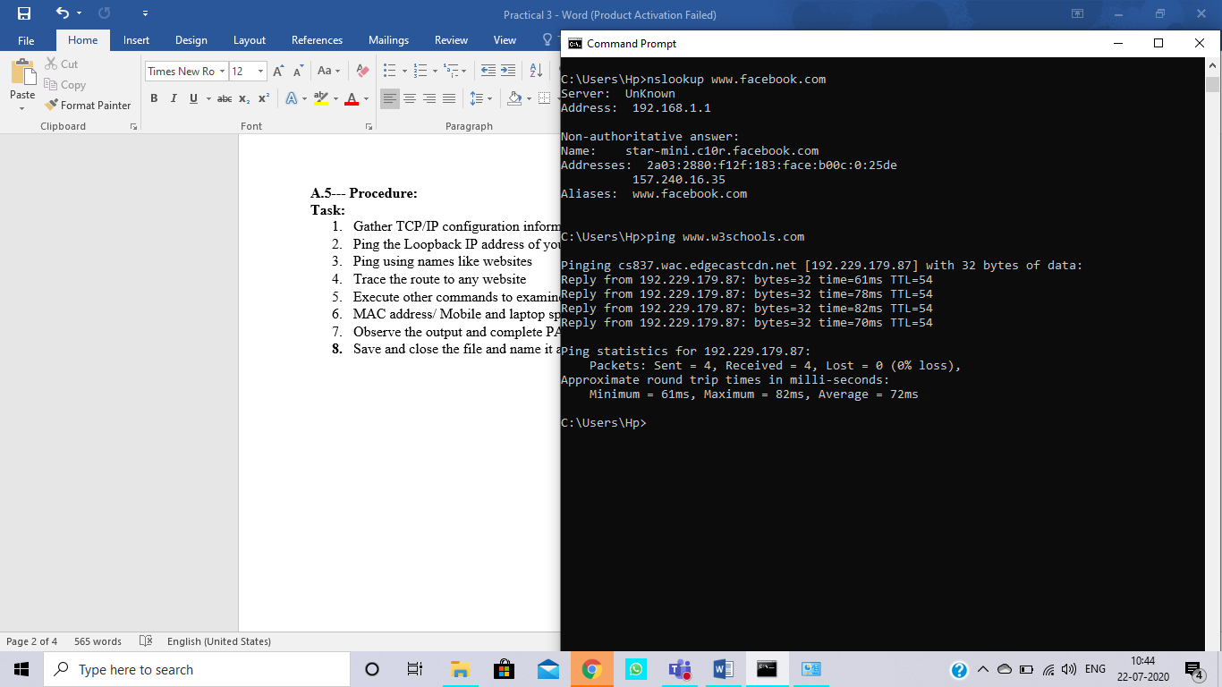

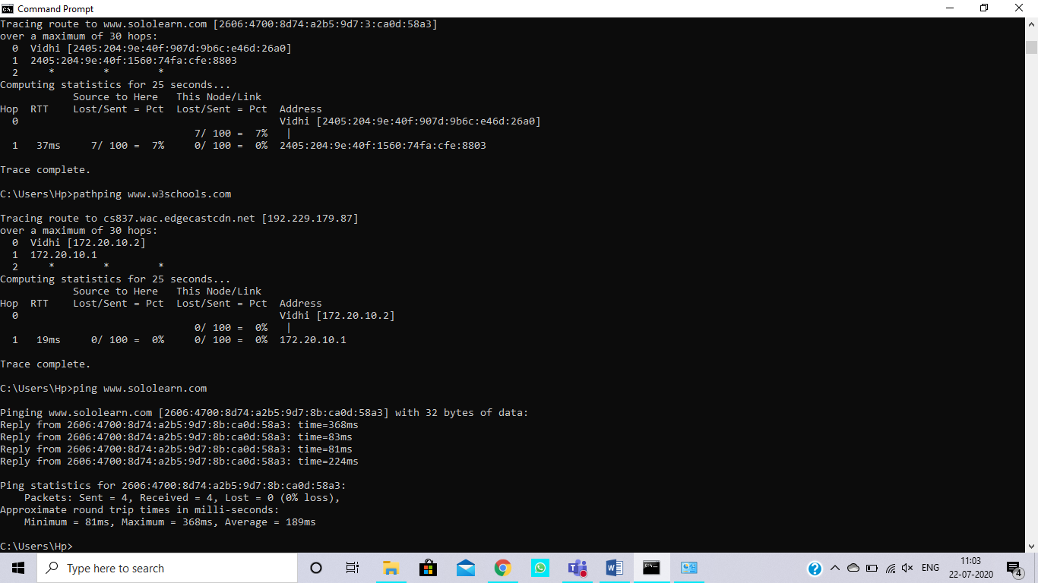

1. Trace the route to any website

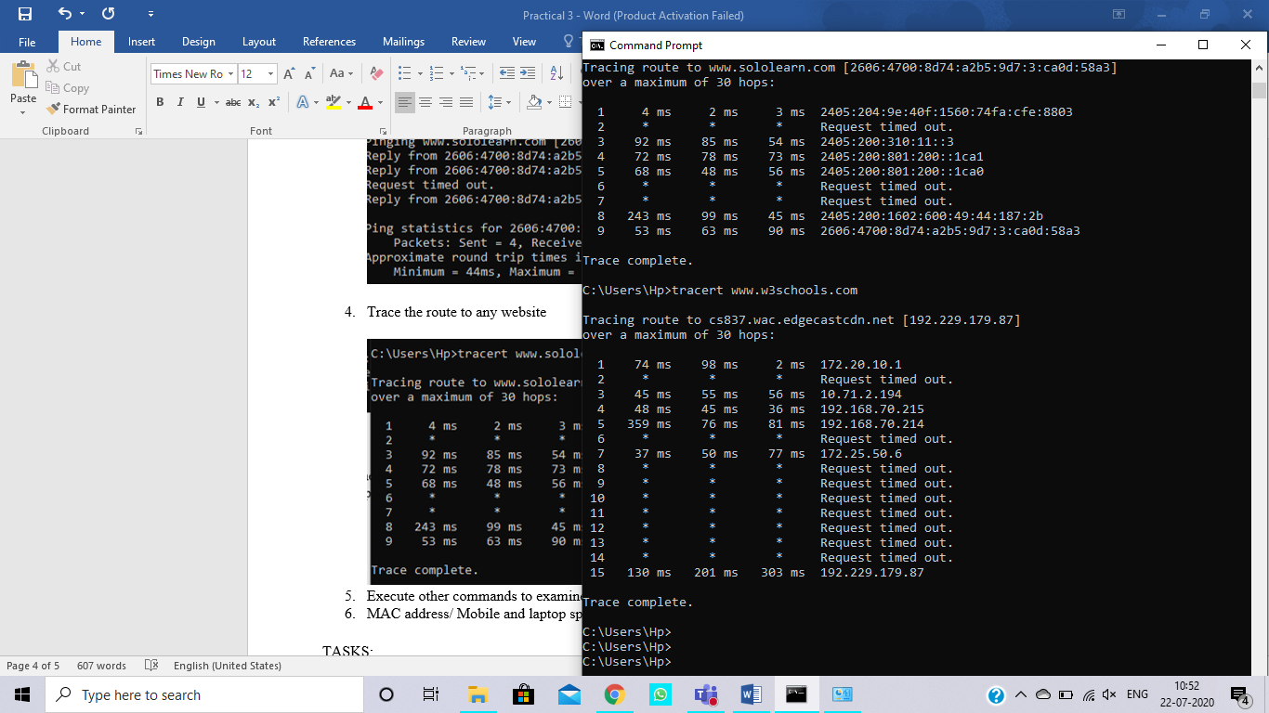

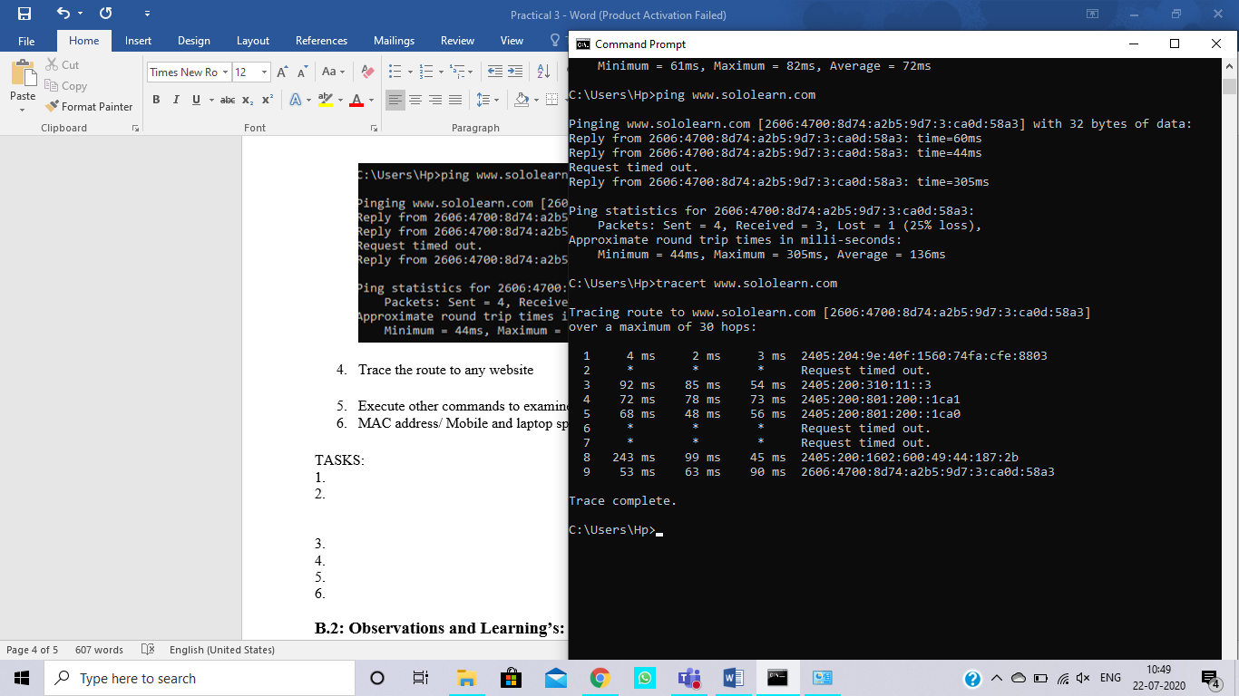

1. Execute other commands to examine a network

PATH PING:

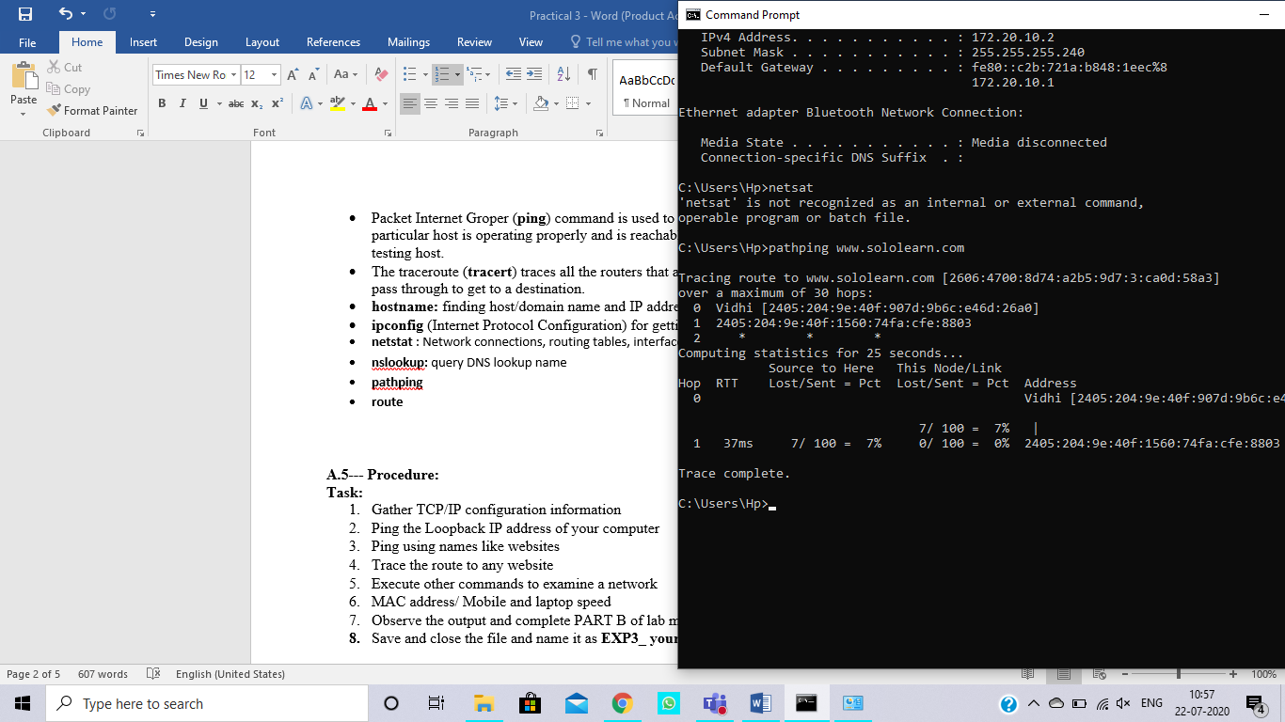



ipconfig:



Netstat:

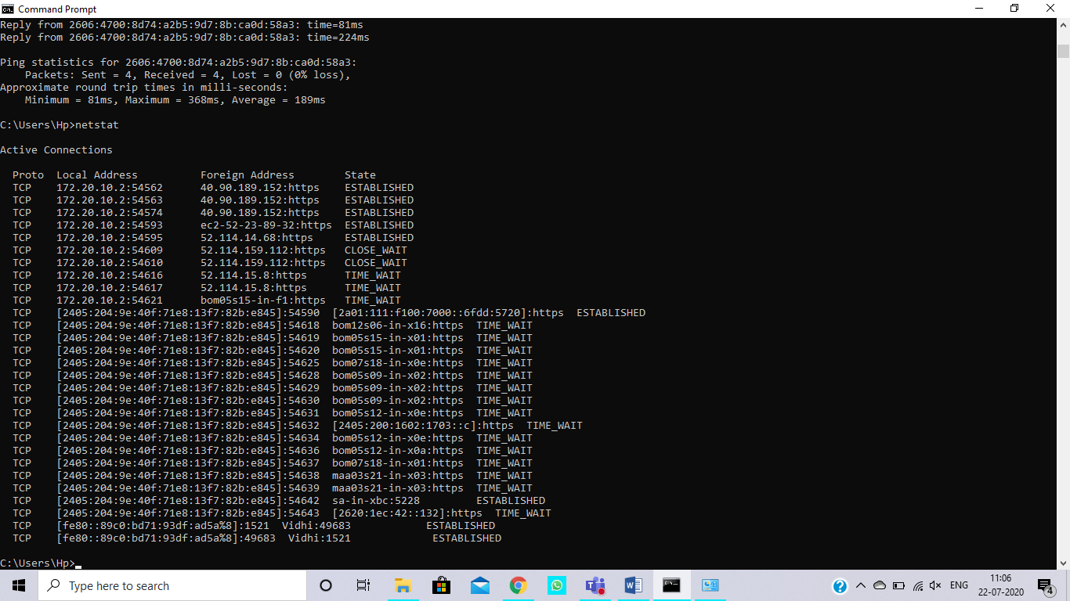

Nslookup

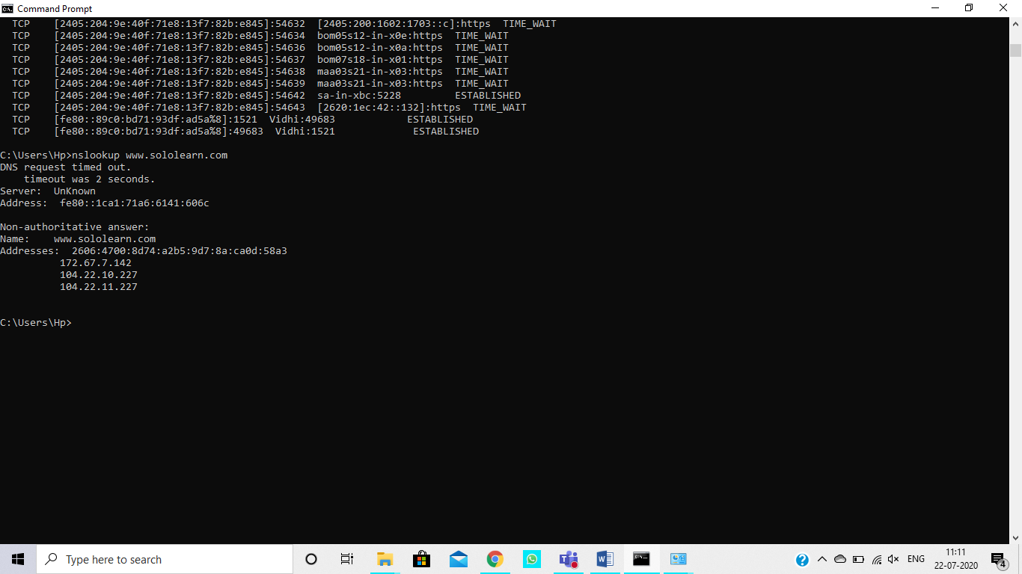

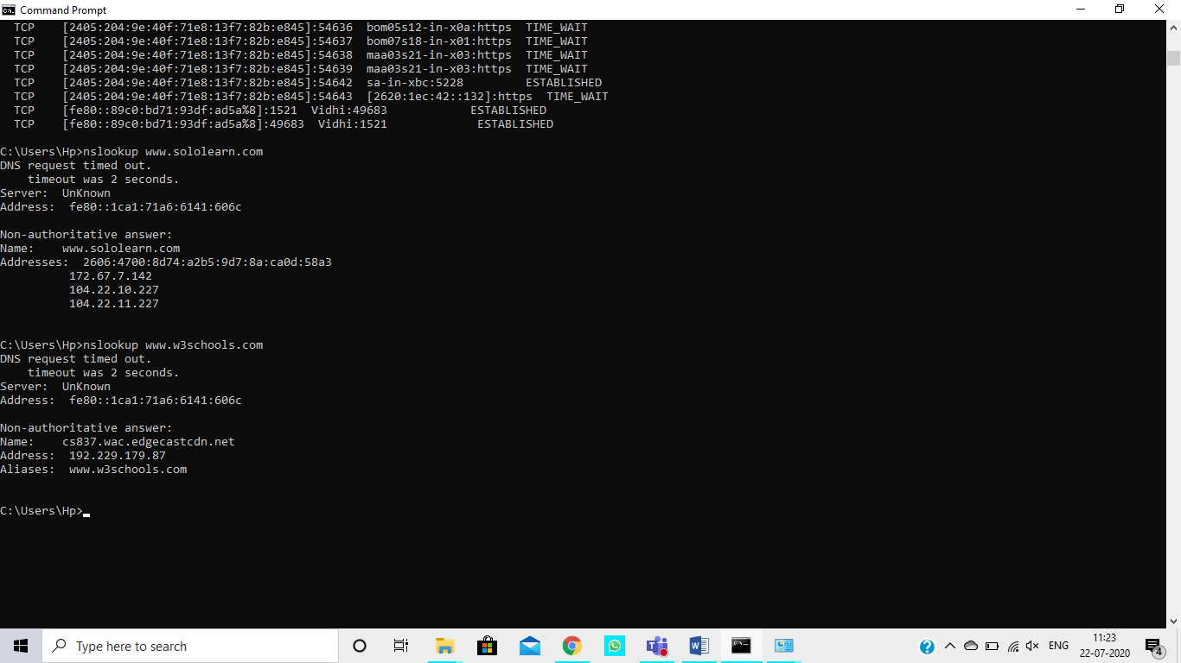

Route:

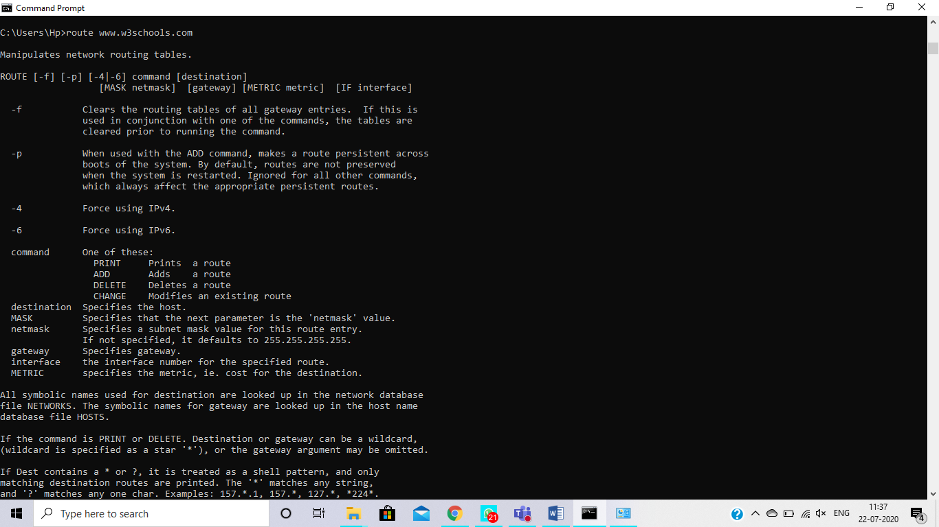

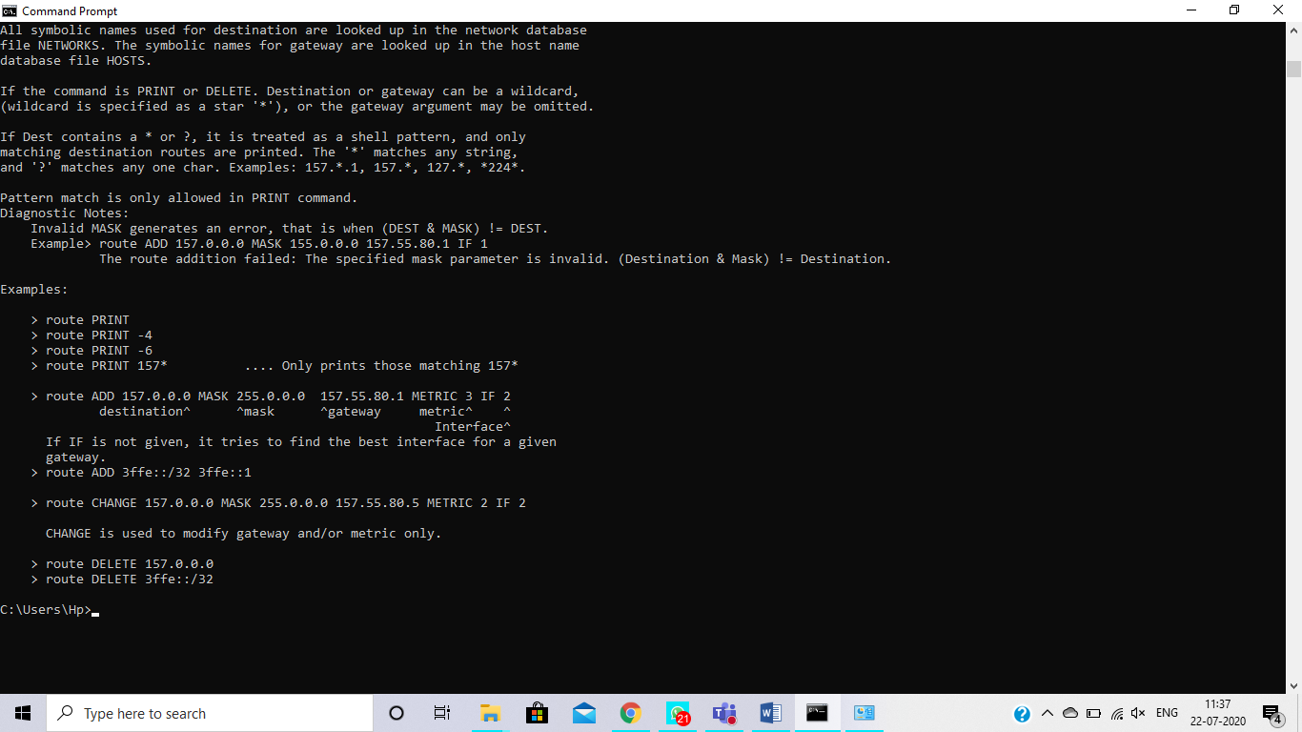

1. MAC address/ Mobile and laptop speed

LAPTOP:

MAC address: 80-C5-F2-F64A-69

Speed:

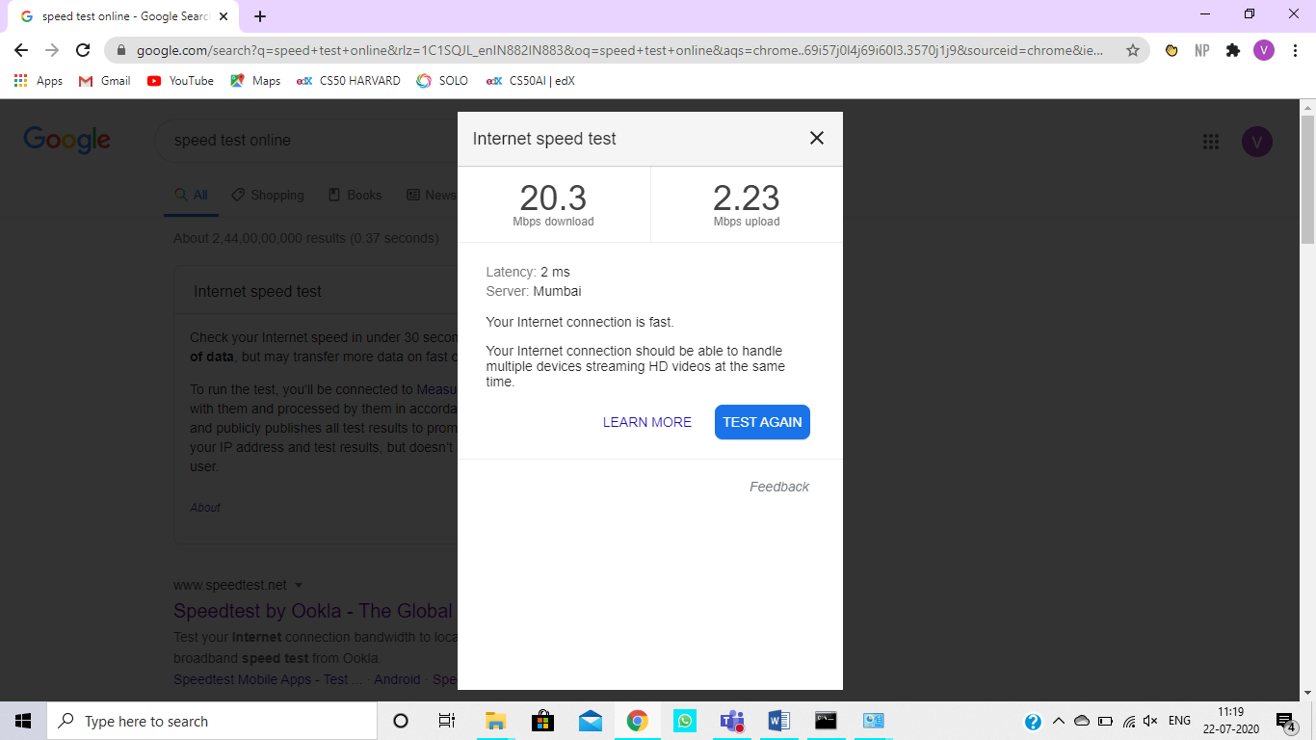

MOBILE:

MAC address: 64:A5:C3:55:99:EA

Speed:

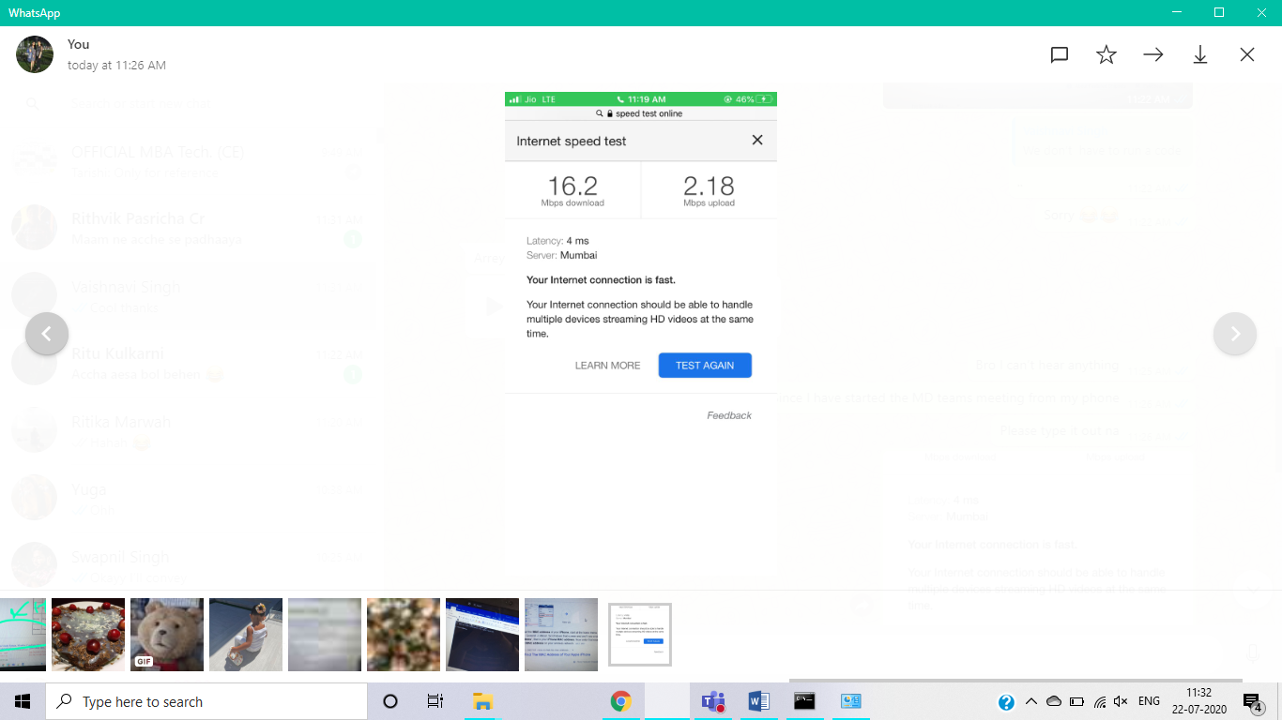

**B.2: Observations and Learning’s:**

In the above experiment, we learnt various commands that will give us details regarding our network. We found out how a request travels from our devices to the server and back. We also checked the speed of internet of out=r laptops and mobile phones.

**B.3: Conclusion:**

An error in connecting to a website can be easily decoded using the commands we learnt in this experiment. We can also find the speed of various networks easily.

### Experiment 4

**B.1: Procedure of performed experiment**

Router0:

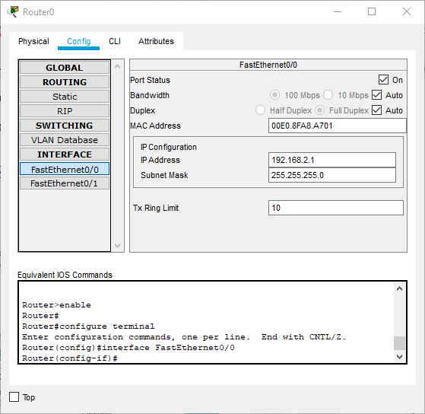

* Under Config, choose FastEthernet0/0 tab and do the following:
  + Enter IP address as 192.168.2.1
  + Set Port Status as “On”.

PC0:

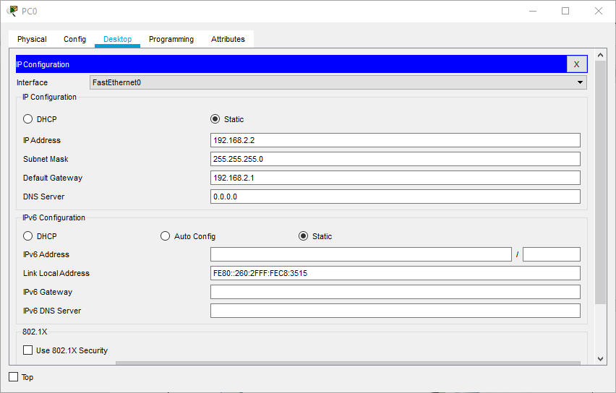

* Under desktop, choose IP configuration and:
  + Set IP Address as 192.168.2.2
  + SetDefault Gateway as 192.168.2.1

AccessPoint0:

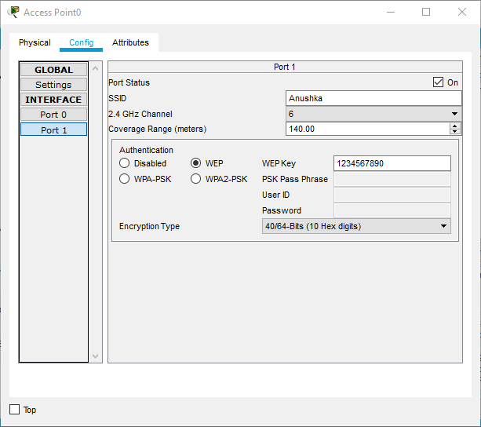

* Under Config, choose Port1 and do the following:
  + Choose WEP
  + Set WEP Key as 1234567890
  + Set SSID as name, here Anushka.

PC1:

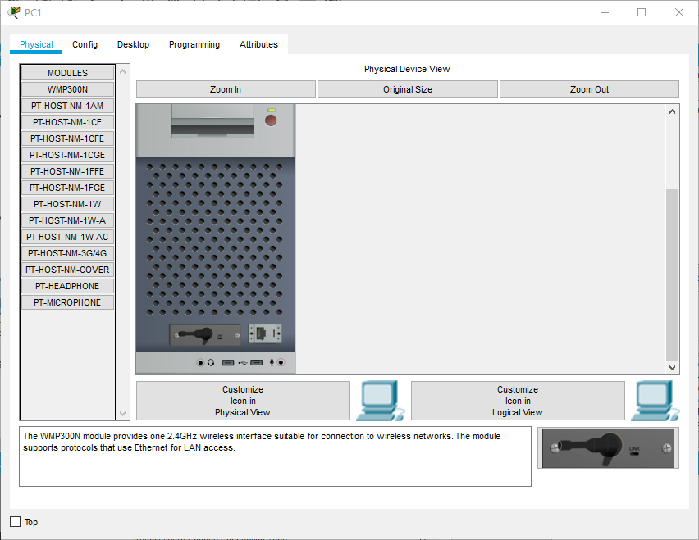

* Under Physical tab, click to Switch Off, change connector to WMP300N and switch back On.

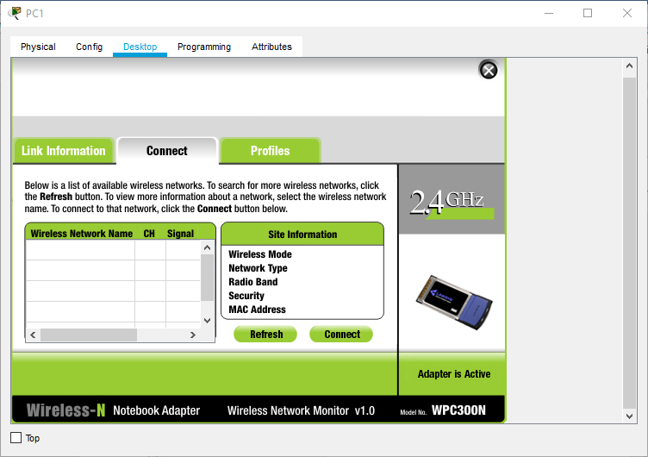

* Under Desktop, choose PC Wireless and do the following:
  + Under Connect-
    - Refresh
    - Choose “Anushka” from Networks
    - Click Connect and enter WEP Key to connect.

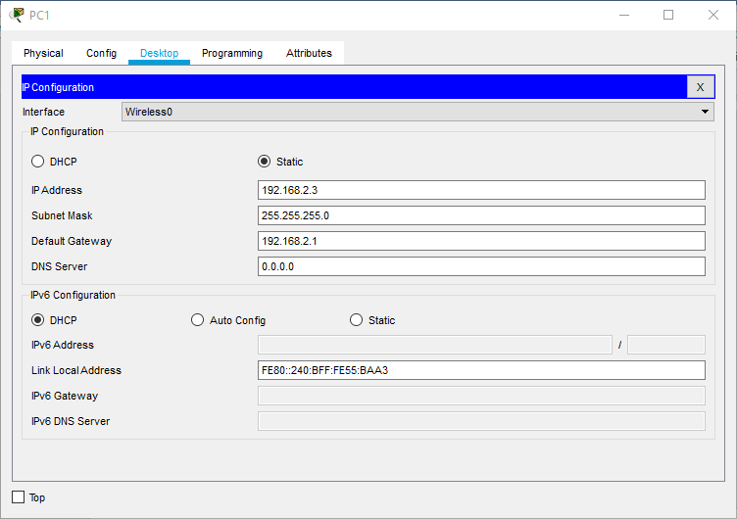

* Under Desktop, choose IP Configuration and do the following:
  + Set IP Configuration as Static
  + Enter IP address as 192.168.2.3
  + Set Default Gateway as 192.168.2.1.

Laptop0:

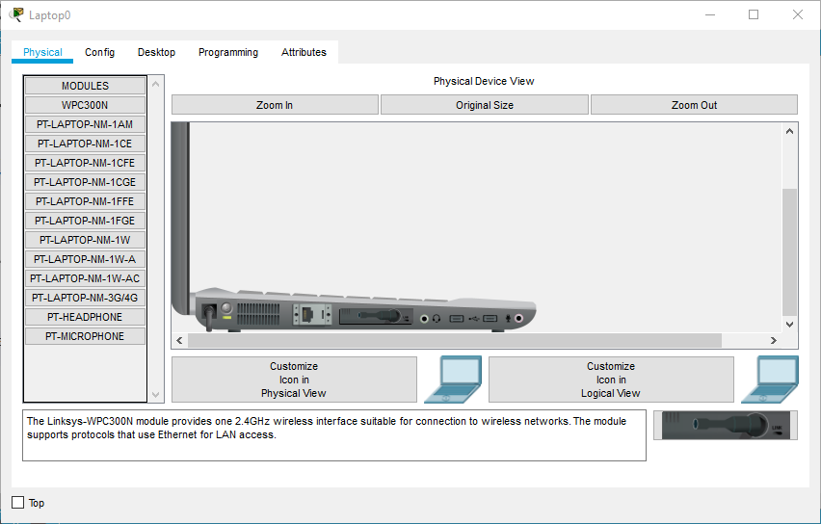

* Under Physical tab, click to Switch Off, change connector to WMP300N and switch back On.

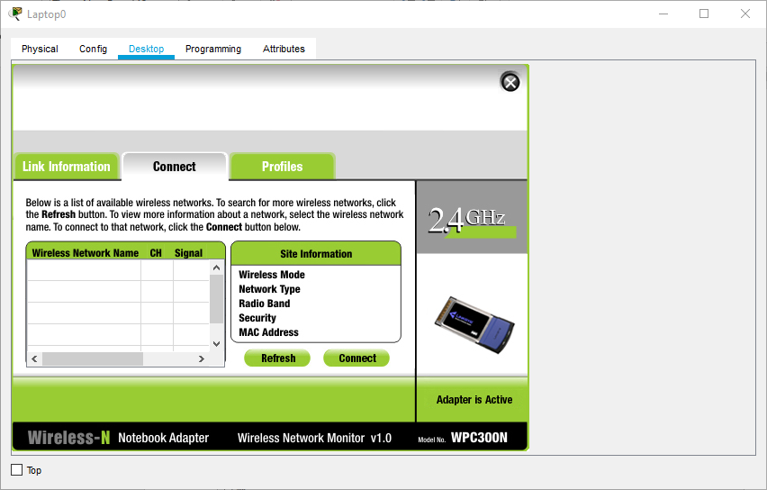

* Under Desktop, choose PC Wireless and do the following:
  + Under Connect-
    - Refresh
    - Choose “Anushka” from Networks
    - Click Connect and enter WEP Key to connect.

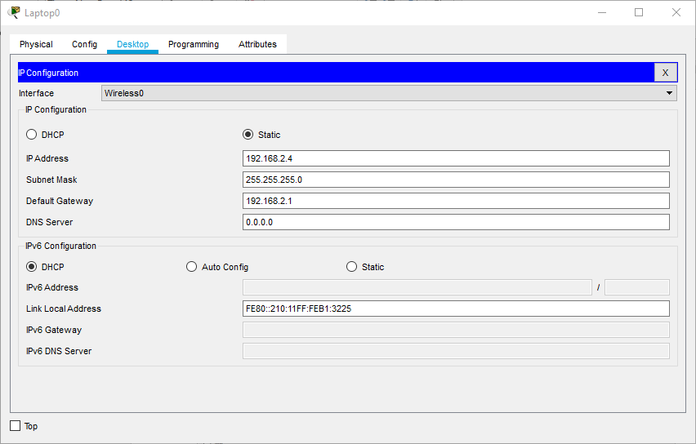

* Under Desktop, choose IP Configuration and do the following:
  + Set IP Configuration as Static
  + Enter IP address as 192.168.2.4
  + Set Default Gateway as 192.168.2.1.

Tablet PC0:

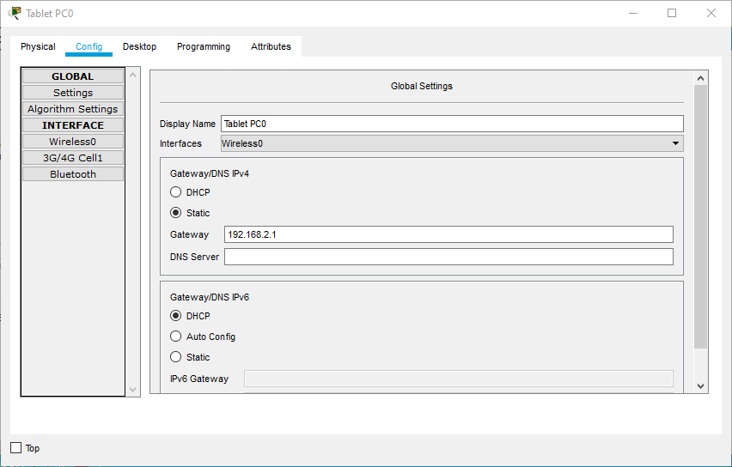

* Under config, set as Static.

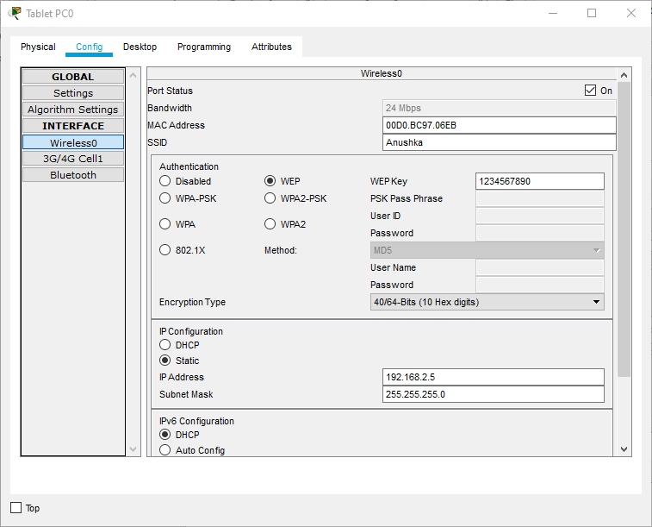

* Under Config, choose Wireless0 and do the following:
  + Choose WEP
  + Set WEP Key as 1234567890
  + Set SSID as name, here Anushka.

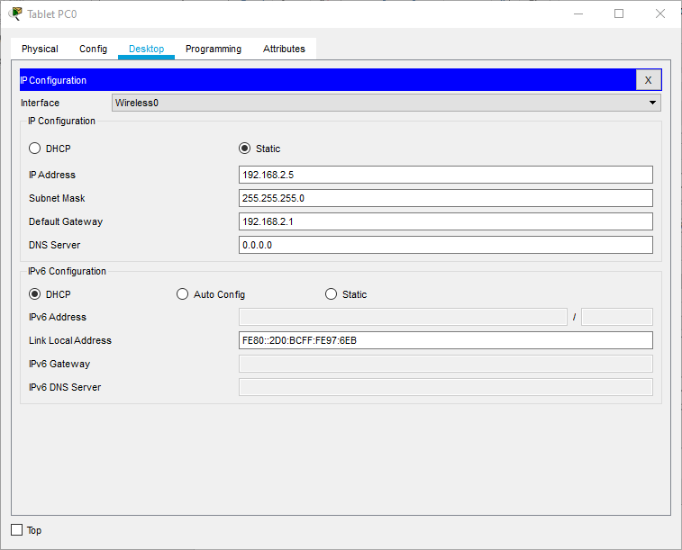

* Under Desktop, choose IP Configuration and do the following:
  + Set IP Configuration as Static
  + Enter IP address as 192.168.2.5
  + Set Default Gateway as 192.168.2.1.

Smartphone0:

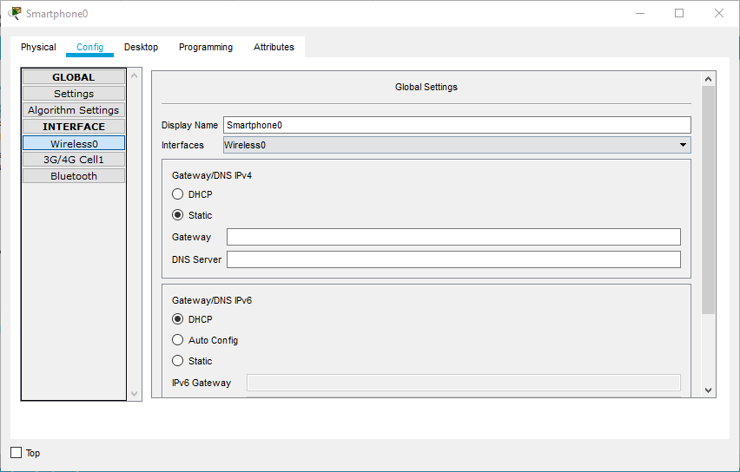

* Under config, set as Static.

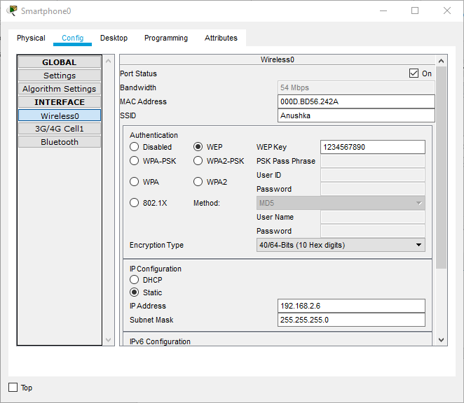

* Under Config, choose Wireless0 and do the following:
  + Choose WEP
  + Set WEP Key as 1234567890
  + Set SSID as name, here Anushka.

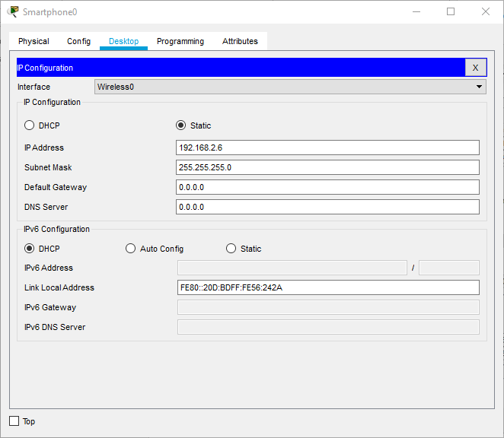

* Under Desktop, choose IP Configuration and do the following:
  + Set IP Configuration as Static
  + Enter IP address as 192.168.2.6

Printer0:

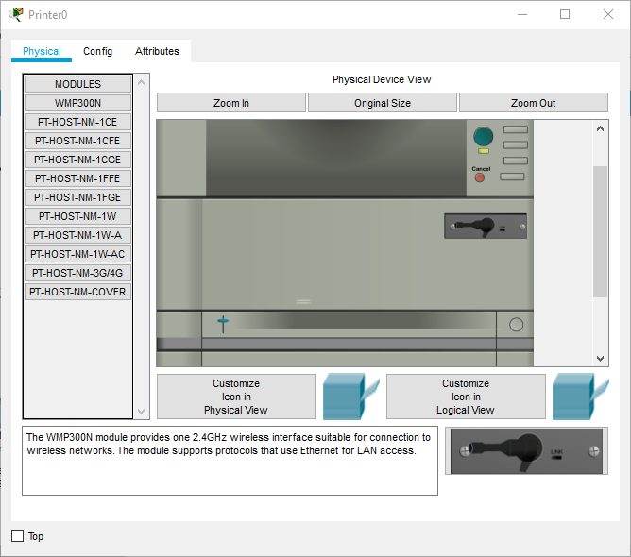

* Under Physical tab, click to Switch Off, change connector to WMP300N and switch back On.

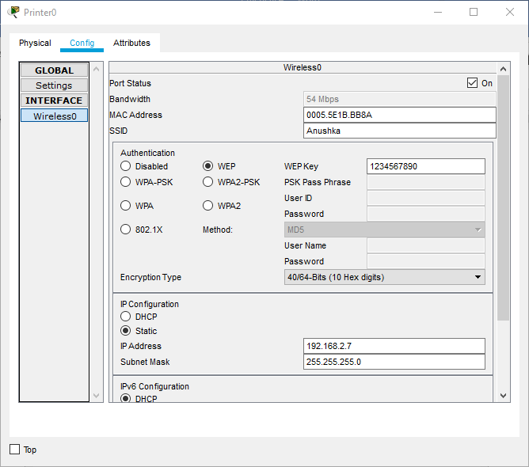

* Under Desktop, choose IP Configuration and do the following:
  + Set IP Configuration as Static
  + Enter IP address as 192.168.2.3
  + Set Default Gateway as 192.168.2.1.
* Under IP Configuration:
  + Set as Static
  + Enter IP address as 192.168.2.7.

Final Network:

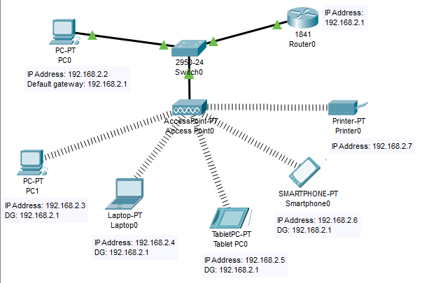

Successful Tests:

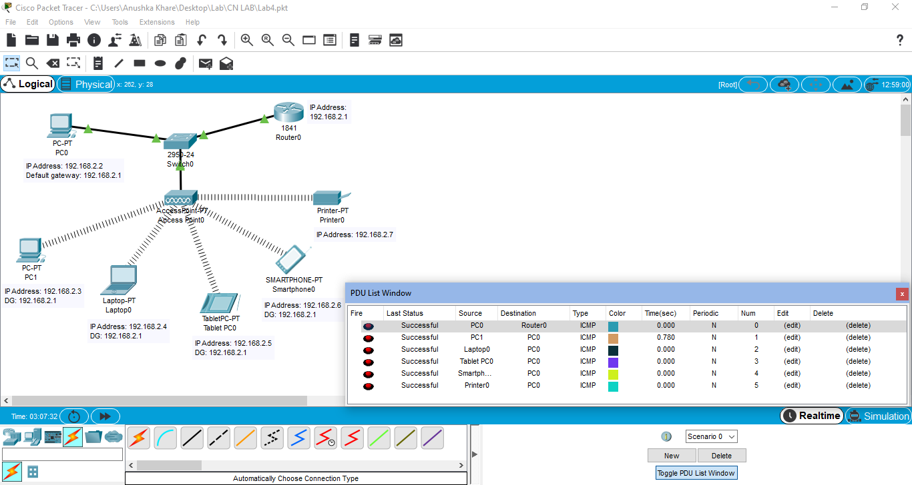

**B.2: Observations and Learning’s:**

Cisco Packet Tracer helps create wireless connections using connecting devices, end devices, connections, etc. and simulate the transmission of packets through the network. It gives information about how the packet travels from the source and the destination as well as the components and path used. Changing the IP information of the devices and creating a functional wireless LAN is also possible. It even lets us change the physical features of end devices as per our requirement.

**B.3: Conclusion:**

I have learnt about the interface of Cisco Packet Tracer and implemented a basic wireless connection establishment by using the same software.

## Experiment 5

**B.1: Procedure of performed experiment**

1. Write usage of cross wired and straight wired cable

Ans:

1.Cross Wired:

a) Connect two computers directly.

b) Connect a router's LAN port to a switch/hub's normal port. (Normally used for expanding network)

c)Connect two switches/hubs by using a normal port in both switches/hubs.

2.Straight wired:

a. Connect a computer to a switch/hub's normal port.

b. Connect a computer to a cable/DSL modem's LAN port.

c. Connect a router's WAN port to a cable/DSL modem's LAN port.

d. Connect a router's LAN port to a switch/hub's uplink port. (Normally used for expanding network)

e. Connect two switches/hubs with one of the switches/hubs using an uplink port and the other one using a normal port.

f. If you need to check how a straight cable looks, it's easy. Both sides (side A and side B) of cable have wire arrangement with the same colour.

2. Write the steps to form a LAN cable using straight and cross wired connections. (Refer the video)

Ans:

Step 1: Strip the cable jacket down from the end.

Step 2: Spread the four pairs of twisted wire apart.

Step 3: Untwist the wire pairs and neatly align them in orientation. Be sure not to untwist them any farther down the cable than where the jacket begins

Step 4: Cut the wires as straight as possible, above the end of the jacket.

Step 5: Carefully insert the wires all the way into the connector, making sure that each wire passes through the appropriate guides inside the connector.

Step 6: Push the connector inside the crimping tool and squeeze the crimper all the way down.

3. Explain the following:

a) Ethernet

Ans: ​ Ethernet is a communication standard that was developed in the early ’80s to network computers and other devices in a local environment such as a home or a building. Ethernet is a wired system that started with using coaxial cable and has successfully progressed to now using twisted pair copper wiring and fiber optic wiring.

b) RJ-45

Ans: ​ RJ45 is a type of connector commonly used for ​Ethernet​ networking. It looks similar to a telephone jack, but is slightly wider. Since Ethernet cables have an RJ45connector on each end, Ethernet cables are sometimes also called RJ45 cables. The "RJ" in RJ45 stands for "registered jack, "since it is a standardized networking interface. The "45" simply refers to the number of the interface standard. Each RJ45 connector has eight pins, which means an RJ45 cable contains eight separate wires. If you look closely at the end of an Ethernet cable, you can actually see the eight wires, which are each a different color. Four of them are solid colors, while the other four are striped.

c) CAT 5 & CAT

Ans: CAT 5: ​Alternatively known as an Ethernet cable or LAN cable, a Cat 5 or category5 is a network cable that consists of four twisted pairs of copper wire terminated by an RJ-45 connector. Cat 5 cable is used in home and business networks, providing data transmission speeds of up to 100 MB per second.CAT 6:​ Cable (Cat 6), is a standardized twisted pair cable for Ethernet and other network physical layers that is backward compatible with the Category 5/5e and Category 3 cable standards. Cat 6 has to meet more stringent specifications for cross talk and system noise than Cat5e and Cat 5e. The cable standard specifies performance of up to 250 MHz, compared to 100 MHz for Cat 5 and Cat 5e.

**B.2: Observations and Learning’s:**

Observed how to arrange each cable properly for LAN cable and how to install it properly.

**B.3: Conclusion:**

Learned how to form a LAN cable using cable, connector, and some other tools.

## Experiment 6

**B.1: Code of performed experiment**

(Students are expected to write the code of performed experiment)

FRAME CONSIDERED:

1. Incoming Packet

2. 52.114.217.146

3. 192.168.1.103

4. 173 Bytes

5. 14 bytes

6. 20 bytes (header) + 159 Bytes

7. 20 bytes (header) +700 Bytes

8.

**B.2: Observations and Learning’s:**

In this experiment, we learnt how packets are sent between IP address. We also saw about the information contained in the packets.

**B.3: Conclusion:**

We conclude that we could successfully retrieve information regarding the packets. We could figure out information like: IP header, TCP header, total number of bytes in a certain frame etc.

## Experiment 7

**B.1: Code of performed experiment**

Program:

Output:

**B.2: Observations and Learning’s:**

The data link layer has the responsibility of error control, which is error detection and correction. Error detecting has many methods like CRC, Simple parity, 2D parity, etc. For error correction, we use Hamming code. In Hamming code, we generate parities based on the data bits and put them in positions that are powers of 2. To get the parity bits, we see the bits related to it, eg: for parity bit 2, the bits related to it are D2, D3, D6, D7 and so on. Basically, bits in groups of 2 at gap of 2 bits are considered. This gives us the final hamming code to be sent to receiver. Hamming code for 4-bit data is: D7 D6 D5 P4 D3 P2 P1. It also gives us the exact position of error, in case of single bit errors.

**B.3: Conclusion:**

I have learnt the concept of error correction and its method, Hamming code. I have also successfully implemented Hamming code as a program.

**B.4: Questions of Curiosity:**

**If there is 1-Bit error. How can it be corrected on the receiver end using hamming code?**

Answer:

Code:

Output:

## Experiment 8

**B.1: Procedure of performed experiment**

**B.2: Observations and Learning’s:**

**Output:**

**B.3: Conclusion:**

We have successfully, executed the sliding window protocol using python programming and displayed the output of the same.

**B.4: Questions of Curiosity:**

**Draw the flow diagram for m=3 with all possible conditions**

## Experiment 9

**B.1 Answers of Task to be written by student:**

Network:

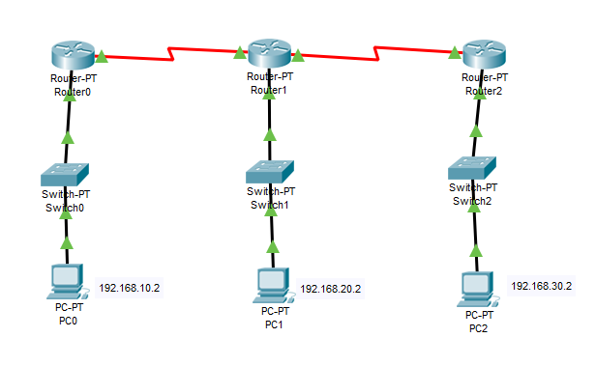

Successful Tests:

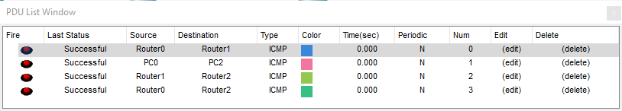

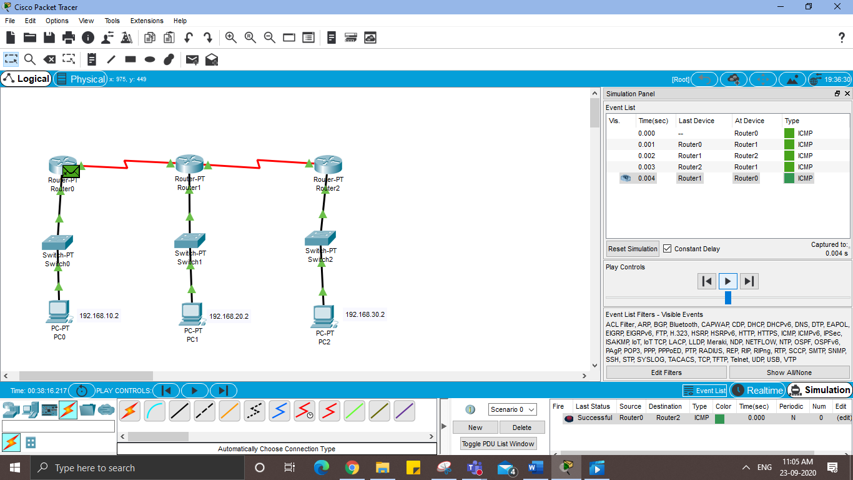

Configurations:

PC0-

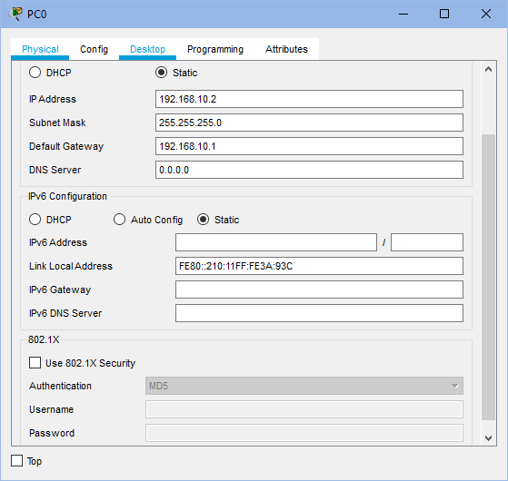

* Under Desktop, choose IP Configuration and do the following:
  + Set IP Address as 192.168.10.2
  + Set Default Gateway as 192.168.10.1

PC1-

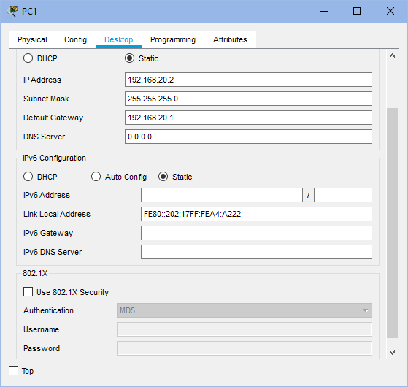

* Under Desktop, choose IP Configuration and do the following:
  + Set IP Address as 192.168.20.2
  + Set Default Gateway as 192.168.20.1

PC2-

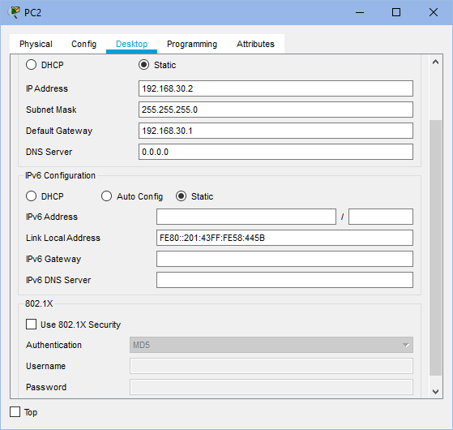

* Under Desktop, choose IP Configuration and do the following:
  + Set IP Address as 192.168.30.2
  + Set Default Gateway as 192.168.30.1

Router0-

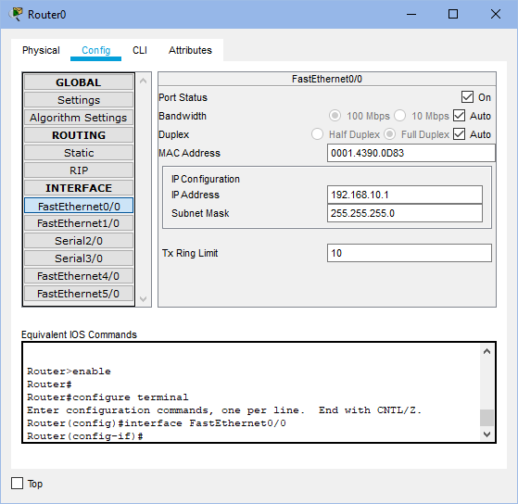 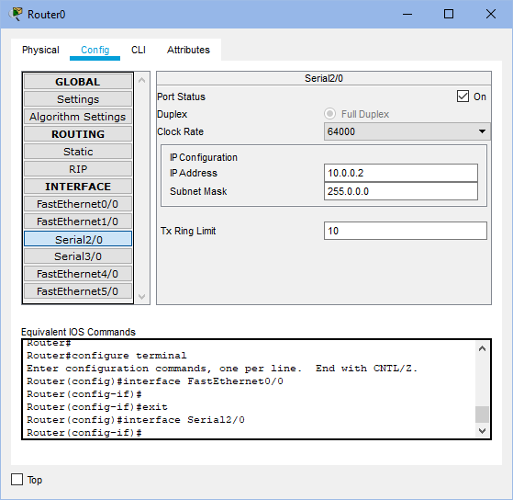

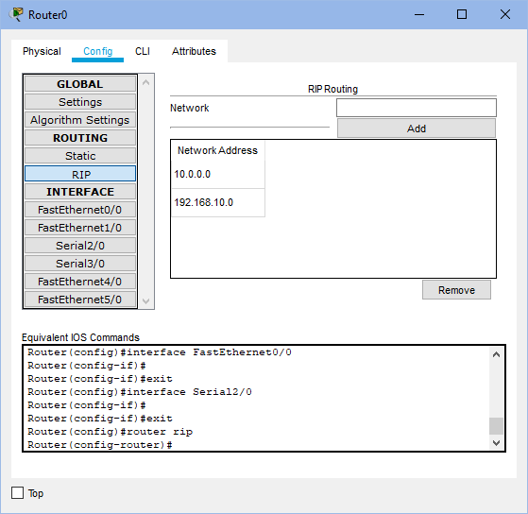

* Under Config tab, do the following:
  + Under FastEthernet0/0-
    - Set IP Address as 192.168.10.1
    - Set Port Status as “ON”
  + Under Serial 2/0-
    - Set IP Address as 10.0.0.2
    - Set Port Status as “ON”
    - Set Clock Rate as 64000
  + Under RIP, add networks 192.168.10.1 and 10.0.0.2

Router1-

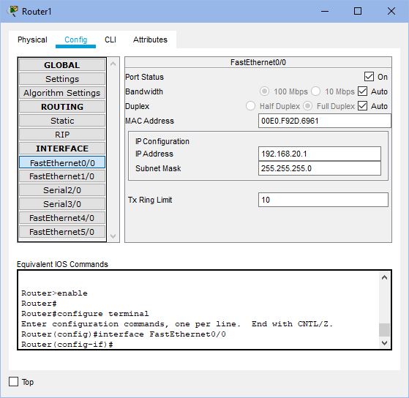 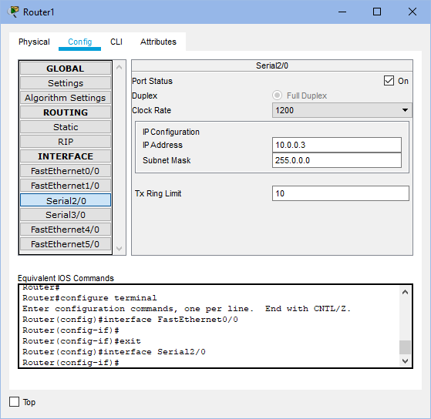

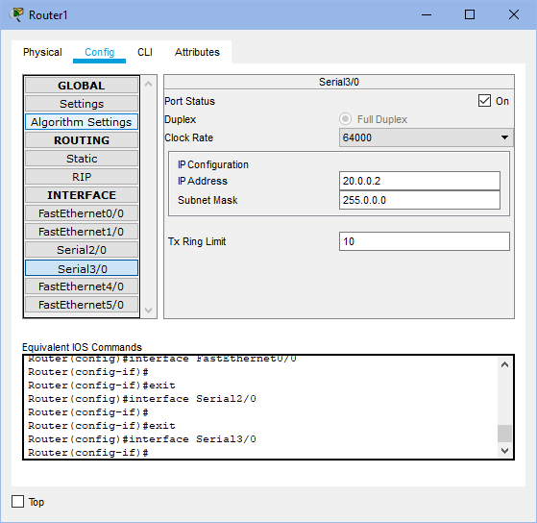 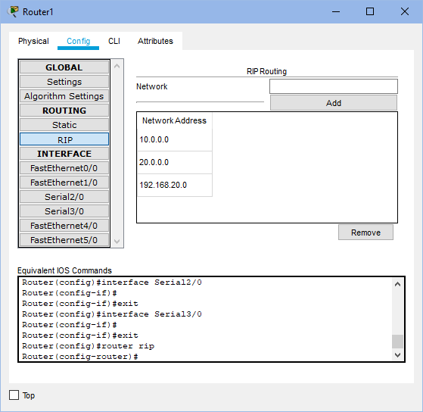

* Under Config tab, do the following:
  + Under FastEthernet0/0-
    - Set IP Address as 192.168.20.1
    - Set Port Status as “ON”
  + Under Serial2/0-
    - Set IP Address as 10.0.0.3
    - Set Port Status as “ON”
  + Under Serial3/0-
    - Set IP Address as 20.0.0.2
    - Set Port Status as “ON”
    - Set Clock rate as 64000
  + Under RIP, add networks 192.168.20.1, 10.0.0.3 and 20.0.0.2

Router2-

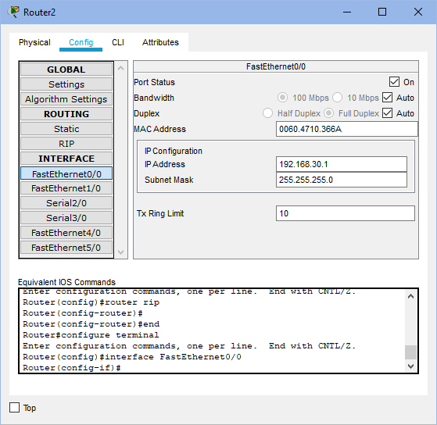 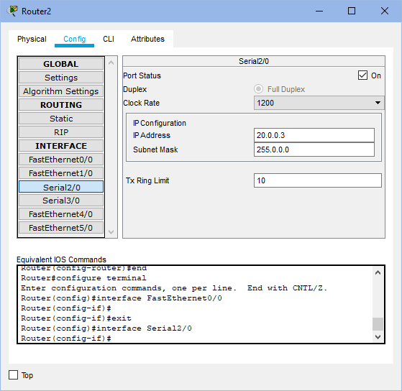

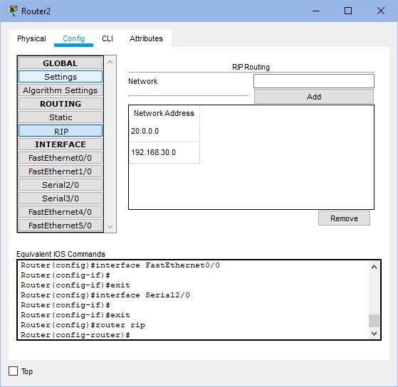

* Under Config tab, do the following:
  + Under FastEthernet0/0-
    - Set IP Address as 192.168.30.1
    - Set Port Status as “ON”
  + Under Serial 2/0-
    - Set IP Address as 20.0.0.3
    - Set Port Status as “ON”
  + Under RIP, add networks 20.0.0.3 and 192.168.30.1

**B.2 Observations and learning:**

Distance Vector Routing is a dynamic routing protocol for intra-domain data transmission in autonomous systems. Each router has its own routing table or distance vector which holds the distance till every other router in the network. Distance vector routing updates the routing table for all the routers parallelly to help decide the next hop for a packet. First, the router checks the direct neighbors and updates its distance vector/table. Then, it uses its direct neighbors’ tables and updates its table again and so on till a path is found to all the other routers in the network.

**B.3 Conclusion:**

I have understood the concept of distance vector routing algorithm and have successfully made a network using Routing Information Protocol in Cisco Packet Tracer.

**B.4 Question of Curiosity**

Q1. Explain Count to infinity problem.

**Answer:** One of the important issues in Distance Vector Routing is County of Infinity Problem or Routing loop. In distance vector routing, routing loops occurs when an interface goes down or when two routers send updates to each other at the same time.  One way to solve this problem is for routers to send information only to the neighbors that are not exclusive links to the destination. Example: there are three routers A, B and C which are connected in series at distance of 1. So, A is directly connected to B, B is directly connected to C but to go from A to C, we have to go via B. If the link between B and C is disconnected, then B will know that it can no longer get to C via that link and will update its table. Before it can send any updates, it’s possible that B will receive an update from A which saying that it can get to C at a cost of 2. B can get to A at a cost of 1, so it will update a route to C via A at a cost of 3. A will then receive updates from B later and update its cost to 4. They will then go on feeding each other bad information toward infinity. This is count to infinity problem.

## Experiment 10

***File Transfer Protocol***

The File Transfer Protocol or FTP is a standard application layer protocol. It runs by transmitting files between different computers that are connected to the internet via the TCP/IP protocol connection. This is a client-server protocol where clients can ask for a file, and local remote servers can provide it.

The machine of the end-user is called the local host and it is connected to the machine running the FTP service (Remote Host) via the internet.

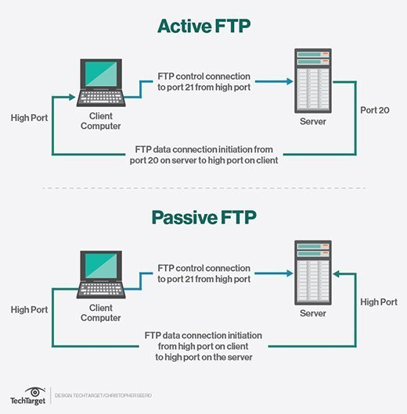

The sessions of FTP protocol can either be in an active mode or passive mode.

**Active Mode**

For active mode, the client first initiates a session with the command channel request, then the server initiates a data connection back to the client and starts to transfer the data.

**Passive Mode**

In passive mode, the command channel information is sent by the server to the client in order to establish a data connection. This allows it to open a data channel with the server and start the receiving of data. This works well across all firewalls and NAT gateways since the client is the one initiating the connection.

**How it Works**

FTP relies on two separate communication channels between the client and the server. This includes a basic command channel for the control of conversation between the client and server, and the other to transfer file content along the data channel.

Clients can initiate the conversation with the server by requesting the download of a file. With FTP, clients can even upload, delete, move, copy, rename, and download files from a server. This would require a user to log on to the FTP server first. However, some servers can make all of their content available without a login, and these are called Anonymous FTP.

Users can find working with FTP to be quite easy with the help of a basic command line interface. This includes the terminal in OS X and Linus, and the PowerShell/Command Prompt in Windows.

**Security**

When FTP was initially created back in 1971, the definitions of TCP and IP were not created. Since then, FTP has been redefined several times in order to adjust to the new versions of TCP/IP. It was also initially defined without any security considerations; however, this has been redefined to overcome those limits. Its extensions such as SFTP or FTPS work well with a TLS connection and ensure security of the data being transferred.

It also does not encrypt any traffic which can allow individuals to capture the packets and read them, along with the usernames and passwords in the packets. FTP can still be vulnerable to brute force attacks, spoofing, packet capture, and FTP bounce. DDoS attacks can also have a severe impact on the functioning of FTP.

**FTP Clients**

The clients of FTP can upload, download, and manage files on the server. Its clients include:

* WinSCP which is a Windows FTC client which supports all iterations of FTP.
* WS FTP which is another FTC client for windows with support for SSH.
* Transmit which is an FTP client for OS X with support for all FTP iterations.

**Summary**

FTP is an excellent application layer protocol for the transmission of files across various computers on the internet. It requires two channels for operations, and the connection is initiated by the client. It isn’t a very secure protocol but has a few extensions that help add security features to it. It relies on FTP clients to manage the data on servers.

**THE END**

**THANK YOU**